Step 3. Sensors
More than one GS5x0 sensor is required for Trimble Earthworks to function. Each of these sensors is connected to the same CAN bus and thus requires assignment so that the system knows which location each sensor is installed on (Boom, Stick, Attachment, Tilt, Etc).
1. Enter the Sensor Assignment menu within the Install Assistant menu.
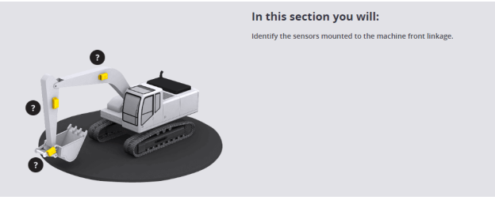
2. Find a suitable site where all listed conditions are met
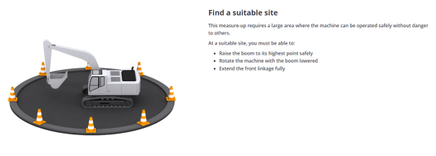
3. Position the machine as directed. The machine must be on stable ground that is
roughly flat.
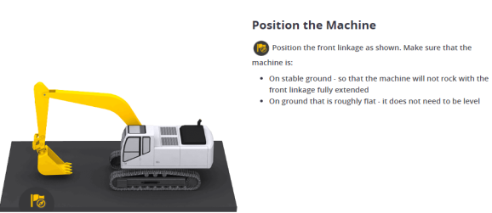
4. If the machine is equipped with a Tilt Bucket/Coupler, you will assign the Tilt
sensor first. If not equipped, select “No Tilt Sensor” and continue with step 4. If
equipped, Select Begin Reading and follow on screen instructions.
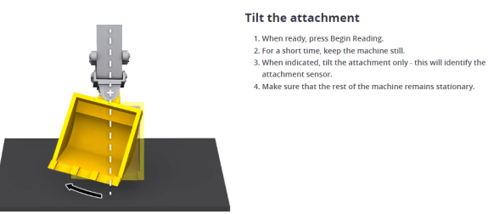
5. Position machine as shown on-screen. The stick should be roughly vertical and
the attachment must be high enough off the ground to fully curl in and out.
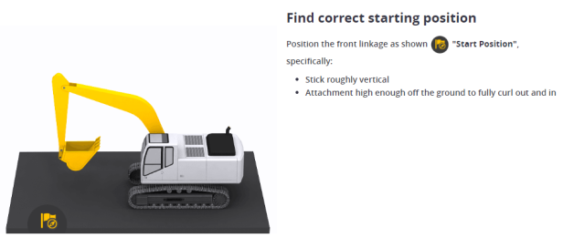
6. Select the mounting position of the dogbone sensor.
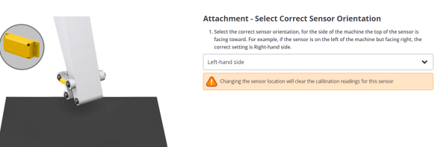
7. Select Begin Reading and move the attachment in and out as prompted. Take
care to wait until the STOP icon disappears.
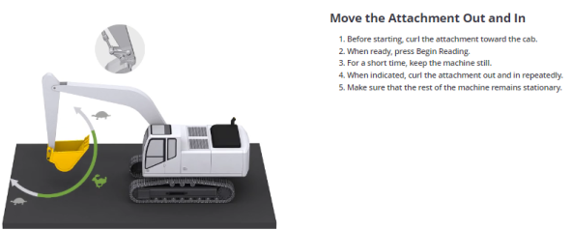
8. Select what side of the Stick the sensor is located on (Right or Left from the
operators screen).
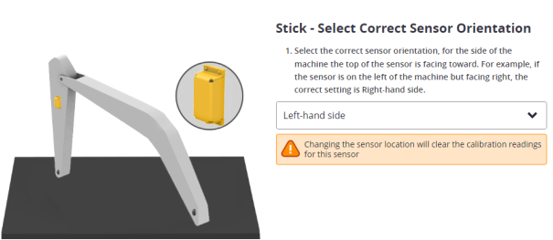
9. Position machine as shown on-screen. Select Begin reading and move stick as
directed on-screen.
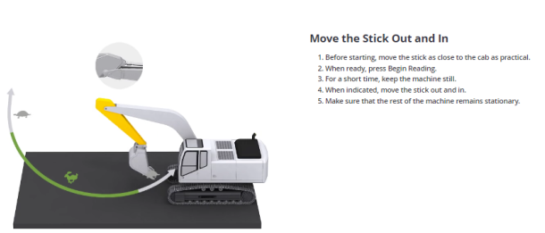
10. If the machine is equipped with a two-part boom, the next step is to determine the sensor for the upper boom. To do this, position the machine as shown. If not equipped, continue with step 12.
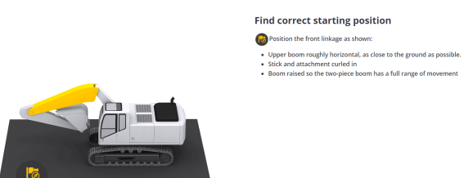
11. Select the upper Boom orientation (Right or Left hand side from the operator's
station).
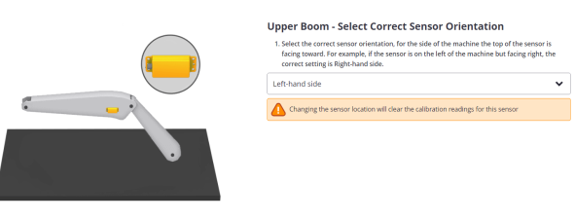
12. Position machine as shown on-screen. Select Begin reading and move upper
boom as directed on-screen.
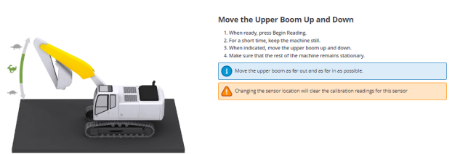
13. Select Boom sensor orientation (Right or Left hand side from the operator's
station).
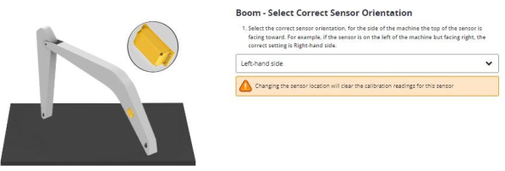
14. Position machine as shown on-screen. Select Begin reading and move the Boom
as directed.
